
PB-T2/ECAK/1221/B 21-APR-2022
PREBOARD EXAMINATION 3 – TERM II (2021-2022)
Answer Key
Subject: ECONOMICS  Grade: XII |  | Max. Marks:40  Time: 2 Hrs
Name: |  |  | Section: | Roll No:
1. | Ans:  The given statement is not correct and is thus refuted. Final goods are those goods which are purchased/consumed either by households or by the producers for investment purpose. ie , these are the goods which have crossed the production boundary.  OR  Ans  The end- use of the machine determines whether it is a capital good or not. Capital goods are those fixed assets of the producers which are used in the process of production for several years and which are of high value. Therefore, only those machines which are used in the process of production are considered to be capital goods. Those machines which are used by the households are not capital goods.  Eg: Computer used at home is a durable- use consumer good, but a computer used in the computer coaching class is a capital good. |  |  |  | (2)
2. | Ans  i)The shaded area AOB represents the dis-savings.  ii) Point B indicates break - even level of income where consumption is equal to income or savings are zero. |  |  |  | (2)
3. | Ans  - False, APS is not always greater than zero, but it can be negative.  - False, Value of investment multiplier varies between one and infinity.  OR  Ans  a) K= 4, Y =4000 crores  b) Change in consumption expenditure = 3000 crores. |  |  |  | (2)
4. | Ans:  The casual labourers do not get regular income; they do not have any protection or regulation from the government and have no job security. They also lack social benefits which permanent workers get. This makes the casual workers vulnerable.  OR  Ans:  Infrastructure contributes to the economic development of a country.  - By increasing the productivity of the factors of production.  - By improving the quality of life of the people. |  |  |  | (2)
5. | Ans  The given statement is defended as in the recent past India has witnessed many foreign nationals visiting for surgeries, organ transplant, dental and even cosmetic care. The major reasons are  - Health services in India offer latest medical technologies with qualified personals.  - All these medical services are less costly in India as compared to similar heath care services in other countries. |  |  |  | (2)
6. | Ans :  - Not a part of domestic product as it is not generated in the domestic territory of the country.  - Not a part of domestic product as it is a transfer payment.  - Part of domestic product as these are exports produced in the domestic territory. |  |  |  | (3)
7. | Ans: -  - Full employment is a situation where those who are able and willing to work are getting work at the prevailing wage rate.  - When AD is greater than AS at full employment, such a situation is known as excess demand or inflationary gap. It is called inflationary because this leads to a rise in general price level of the economy.  Diagram |  |  |  | (3)
8. | Ans  - It implies that the resource extraction is not above the rate of regeneration of the resources and wastes generated are within the assimilating capacity of the environment.  - The environment is able to perform its functions uninterruptedly so long as the demand for these functions is within the carrying capacity of the environment. This means that the resources are not extracted beyond the rate of their regeneration. If there is a disequilibrium, the environment fails to replenish itself and it will lead to environmental crisis. Thus, to maintain a healthy environment, the carrying capacity of the environment must be valued and respected. |  |  |  | (3)
9. | Ans  The given data shows that China has gained economic strength over the years. When many developed countries were finding it difficult to maintain a growth rate of even 5% , China was able to maintain near double-digit growth during the decade of 1980s. The growth rate of China has decelerated to an average of 6.8%, over the period of 2015-17. In the recent past India has posted a decent rise in the growth rate. While India had maintained a reasonable growth rate of 5.7% in the decade of 1980’s .It has shown great caliber and character in the period 2015-17 by registering an average of 7.3%, over the period 2015-17. |  |  |  | (3)
10. | Ans  - India, Pakistan and China have started towards their development path at the same time. India and Pakistan become independent nations in 1947, While People’s Republic of China was established in1949.  - Till the 1980’s all the three countries had similar growth rates and per capita incomes.  - Economic reforms took place in the three countries. Reforms started in India in1991, in China 1978 and in Pakistan in 1988. |  |  |  | (3)
11. | Ans : Externalities refer to the benefits(or harms) which a firm or an individual causes to another for which they are not paid(or penalized)  Eg – Air pollution by a sugar mill.  Negative externality reduces welfare through its negative impact on health.  OR  a) Money flows are opposite to real flows. How?  Money flows are opposite to real flows. Because money flows are in response to the real flows.  Example:  There is a real flow of goods and services from the producers to the households. It is in response to it, that the households make payments to the producers. So that, money flows from the households to producers in terms of consumption expenditure. Likewise, there is a real flow of factor services from the households to the producers. It is in response to it, that the producers make payments to the households. So that, money flows from producer to the households in terms of factor payments.  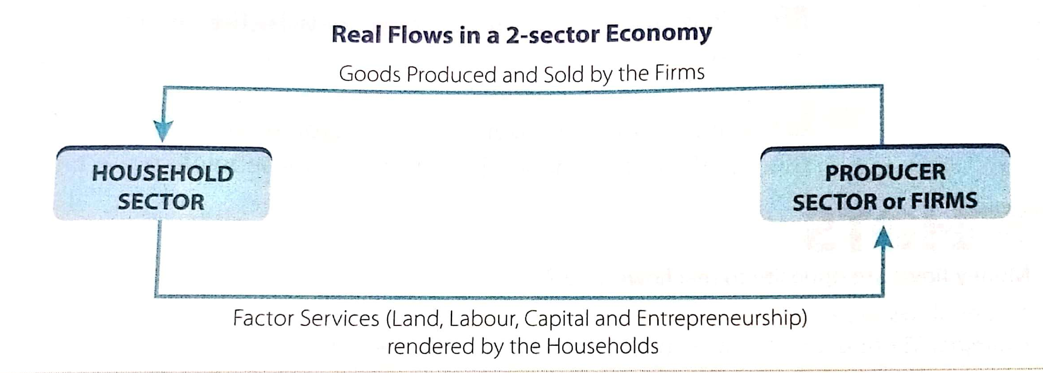  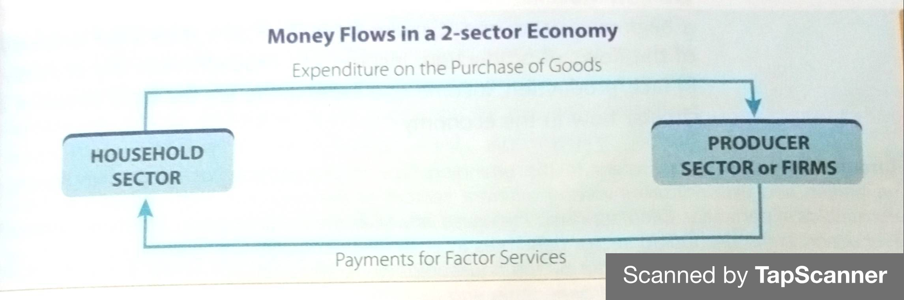  Ans  Sales = (1300+ 80-60+700+50 = ₹2,070 lakh) |  |  |  | (3)  (2)  (3)  (2)
12. | Ans  According to this approach, equilibrium GDP is achieved when S=I. Since S refers to withdrawal from the circular flow and I refer to injection into the circular flow, we can also state the equilibrium condition as the one where  Withdrawal = Injection.  Equilibrium is struck when  S=I=20 crores  Equilibrium Income (GDP)=100 crores  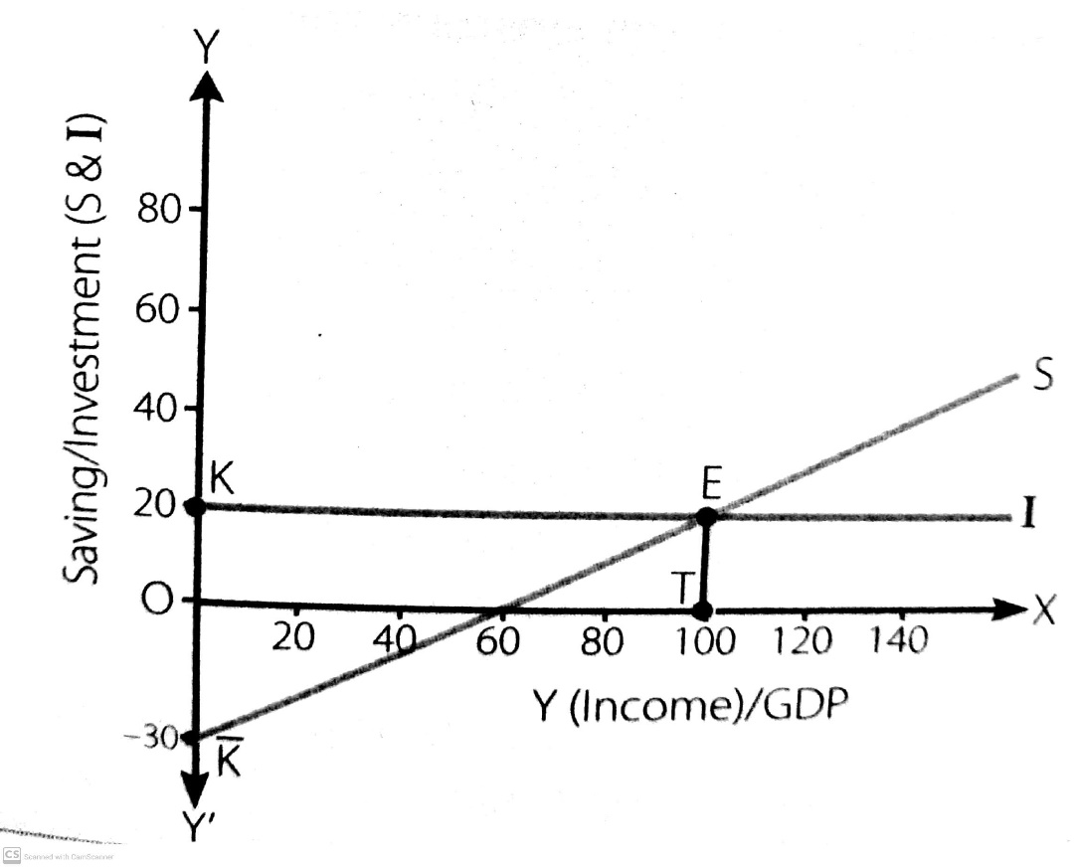  OK is constant investment, independent of the level of income.  E is the point of equilibrium where S=I  OT is the equilibrium income or equilibrium GDP =100.  - In case S is greater than I ,it implies a situation when withdrawal of expenditure (S) is greater than the injection of expenditure (I)into the circular flow of income. Accordingly, overall expenditure in the economy would remain lower than what is required to buy the planned output. Some output would remain unsold. And producers will have undesired stocks. To clear their stocks, the producers would now plan lesser output. This would mean lesser income in the economy. And lesser income implies lesser savings. The process would continue till S=I. Thus, the equality between S and I is restored through change in the level of Y. |  |  |  | (5)
  Y(GDP) | C | S | I
  0 | 30 | -30 | 20
  20 | 40 | -20 | 20
  40 | 50 | -10 | 20
  60 | 60 | 0 | 20
  80 | 70 | 10 | 20
  100 | 80 | 20 | 20
  120 | 90 | 30 | 20
  140 | 100 | 40 | 20
13. | Ans  - Day -to-day, unemployment rate is increasing in India and becoming an enormous problem. In recent times due to various reasons joblessness has become a regular trend in India. The given graph revealed that unemployment rate was over 6% in year 2018 which is approx double of 2021 that is 3.53 percent. From year 2011, there was continuous increase in unemployment rate till 2018 in India,  - Disguised unemployment.  b) “There are some urgent environmental problems faced by India currently.” Justify the statement.  Ans  - Land degradation  - Bio-diversity loss  - Management of fresh water  - Air pollution |  |  |  | (3)  (2)
***

